Check Writer Program
Goal: Convert numeric amount → words (for checks).

Level 0 (High-level abstraction)

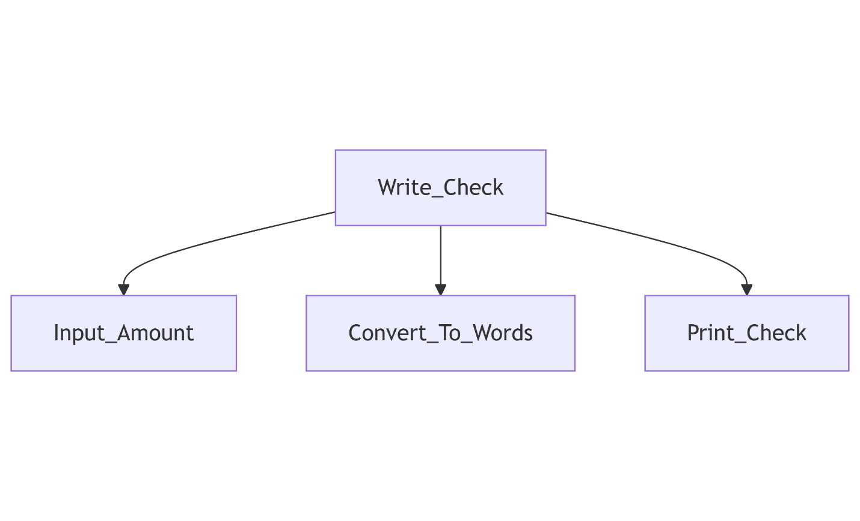
Level 1 (Refining Convert_To_Words)
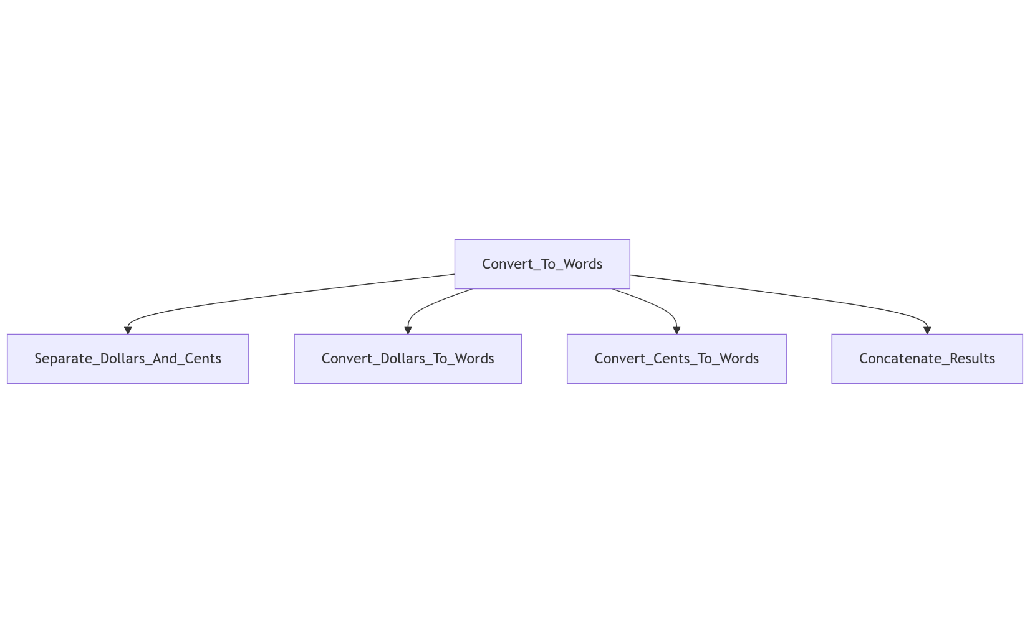
Level 2 (Refining Convert_Dollars_To_Words)

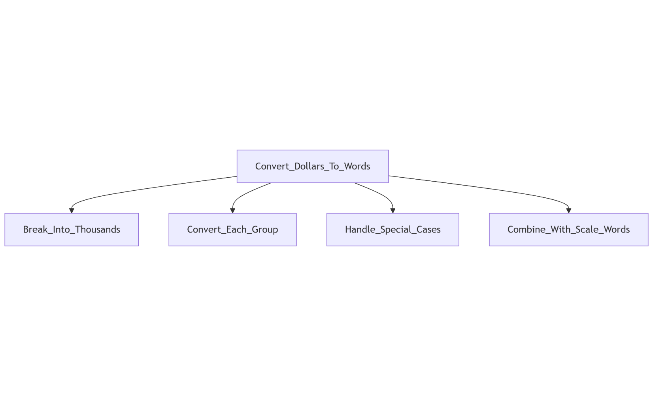

Full Stepwise Refinement Diagram (Check Writer)
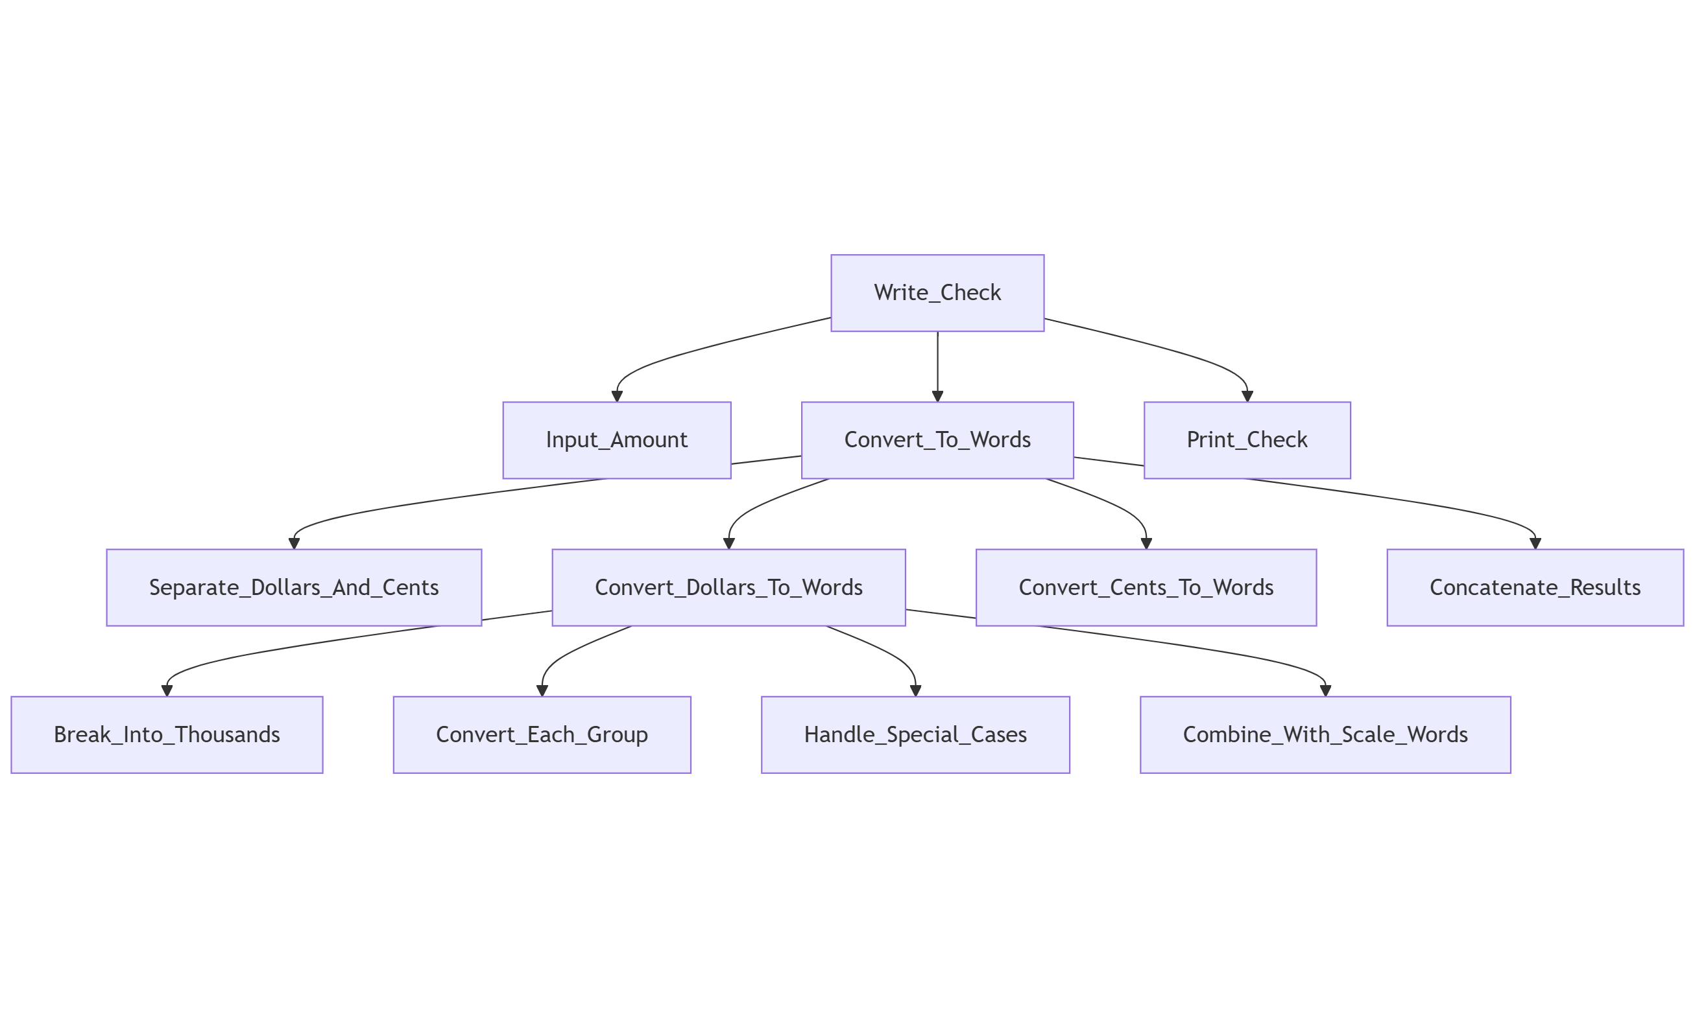
Iteratively Solve for the Roots of a Transcendental Equation
Level 0 — Top-Level Procedural Abstraction
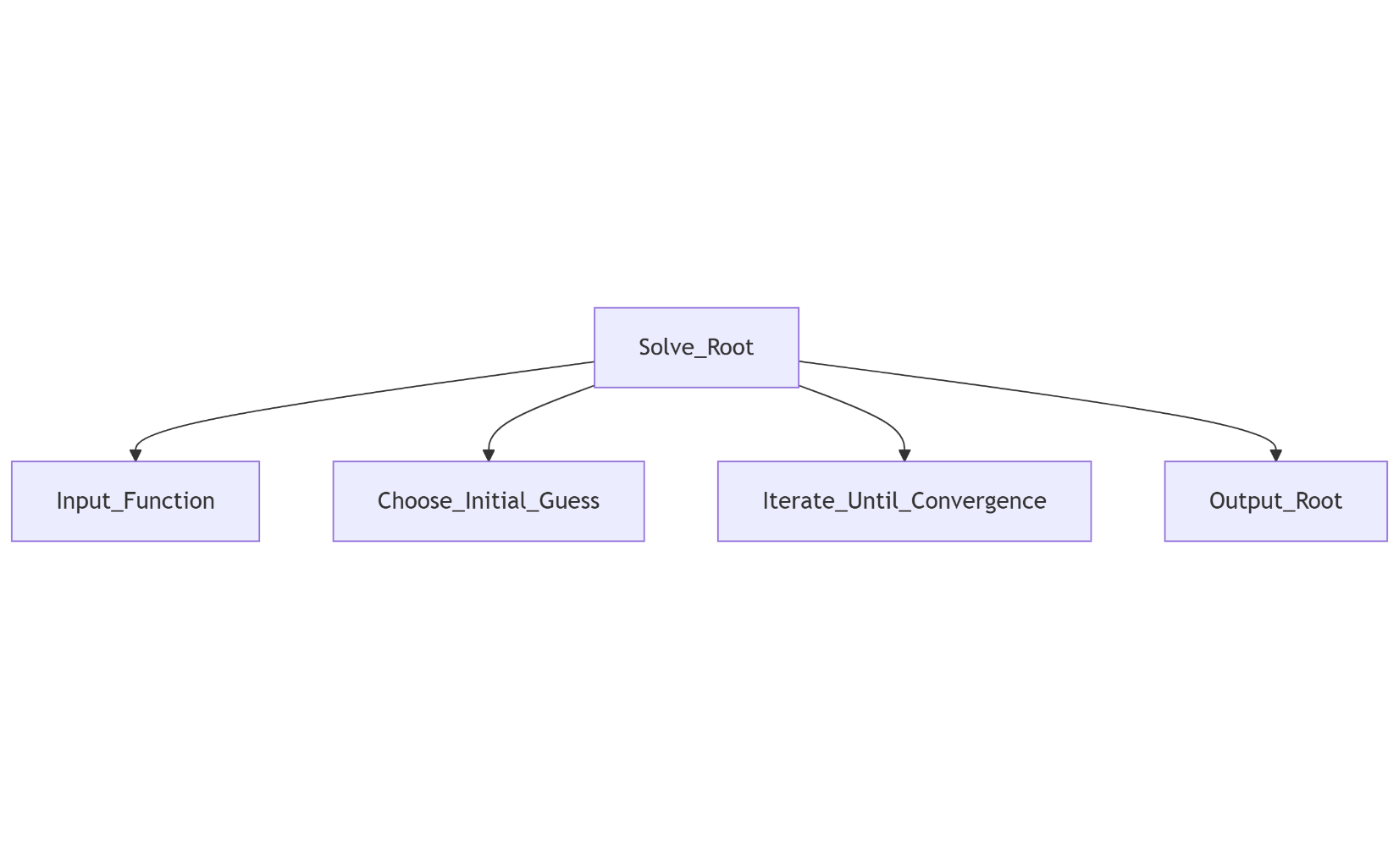

Level 1 — Refinement of Iterate_Until_Convergence
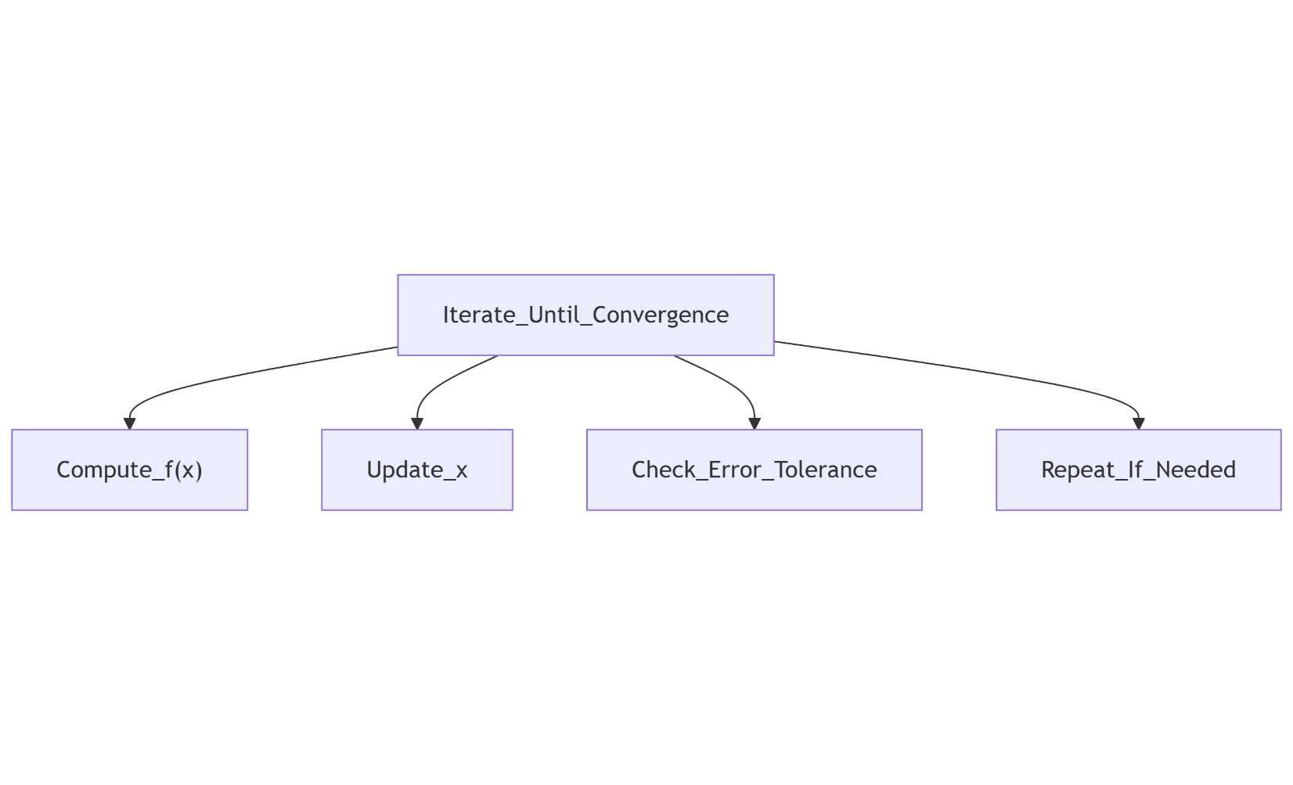

Level 2 — Refinement of Update_x
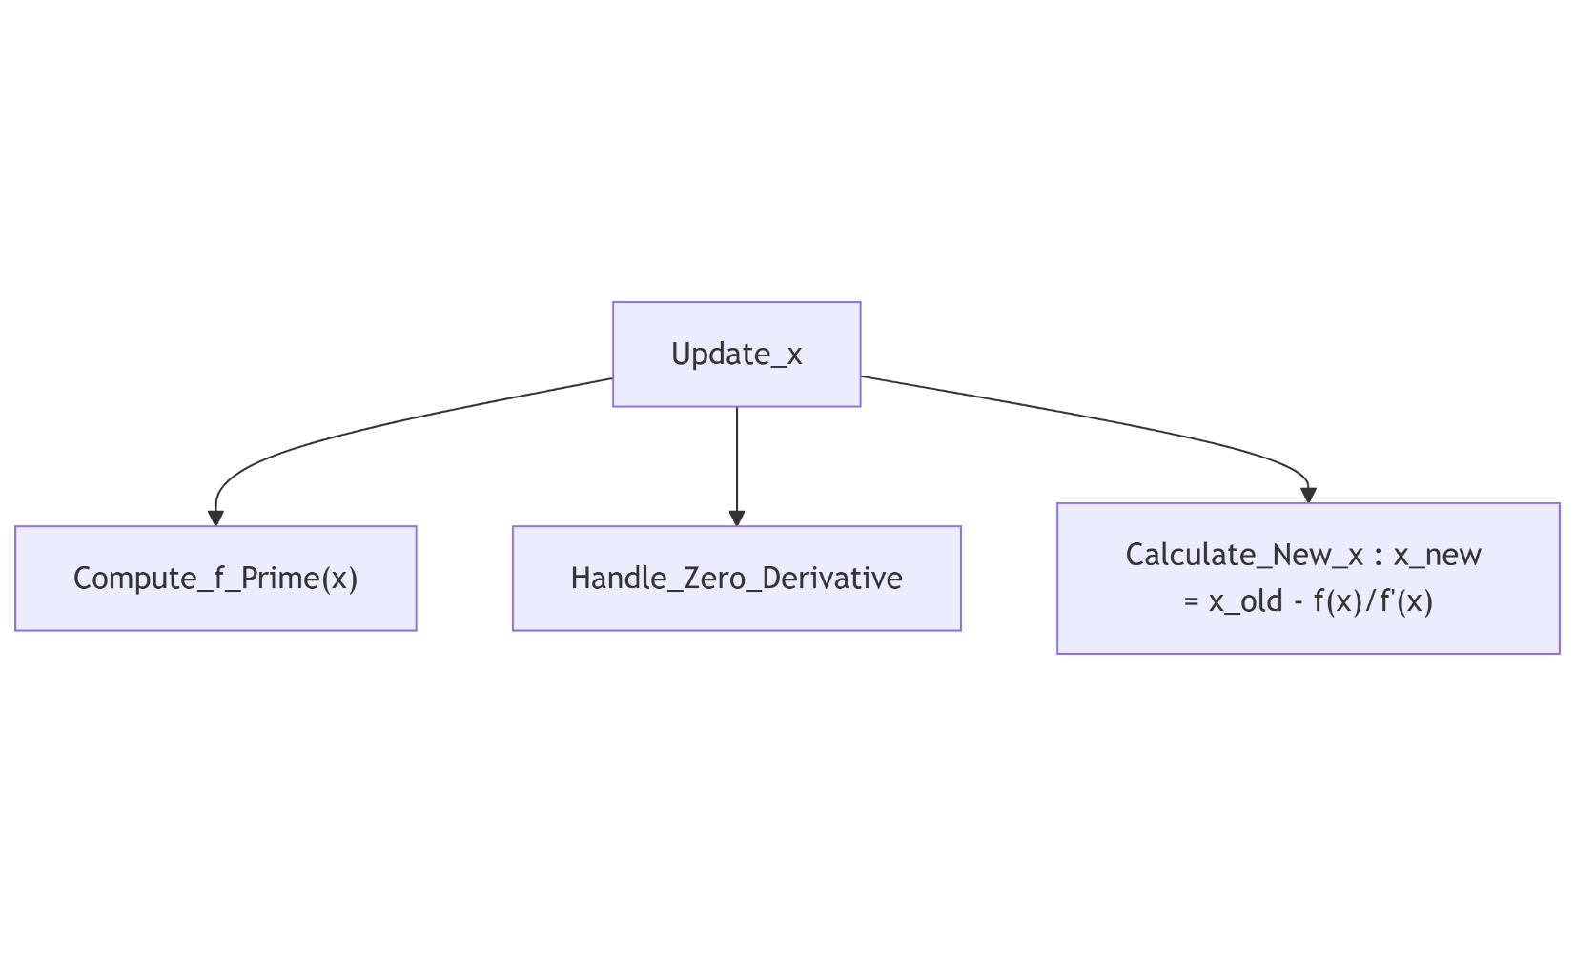

Full Stepwise Refinement Diagram
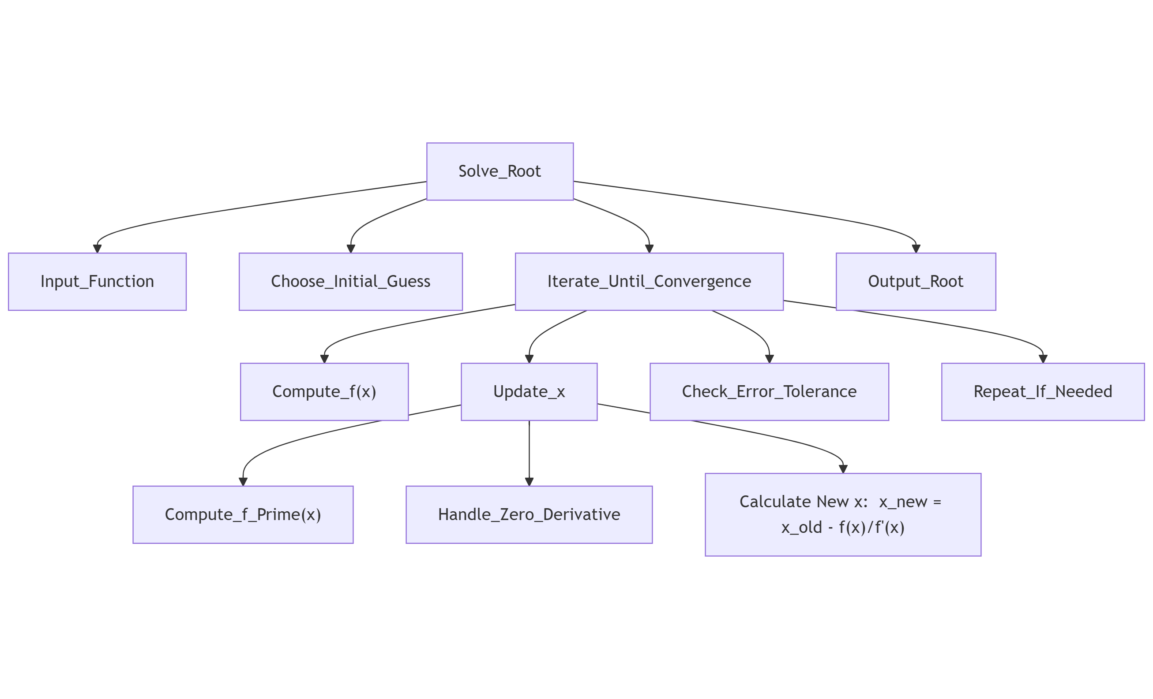
Simple Task Scheduling Algorithm (Operating System)

Level 0 — Top-Level Procedural Abstraction
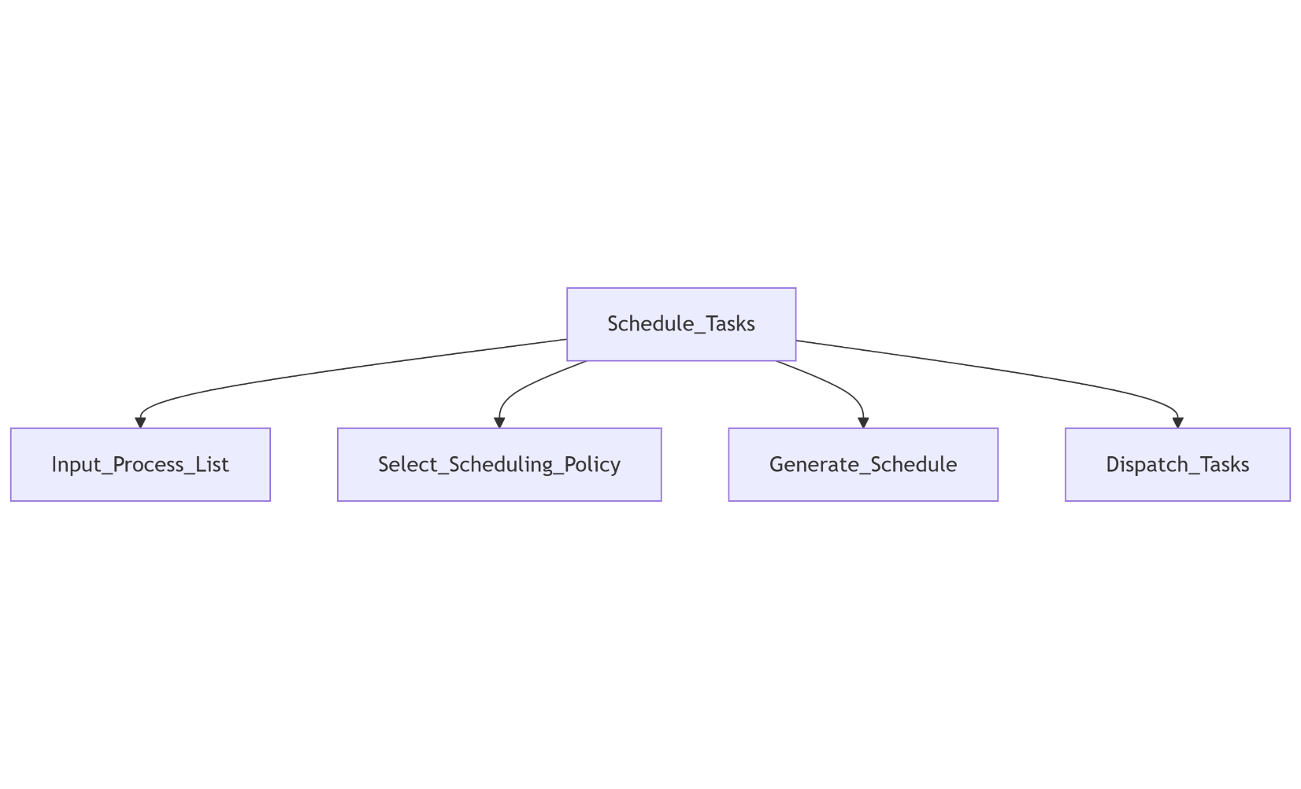

Level 1 — Refinement of Generate_Schedule
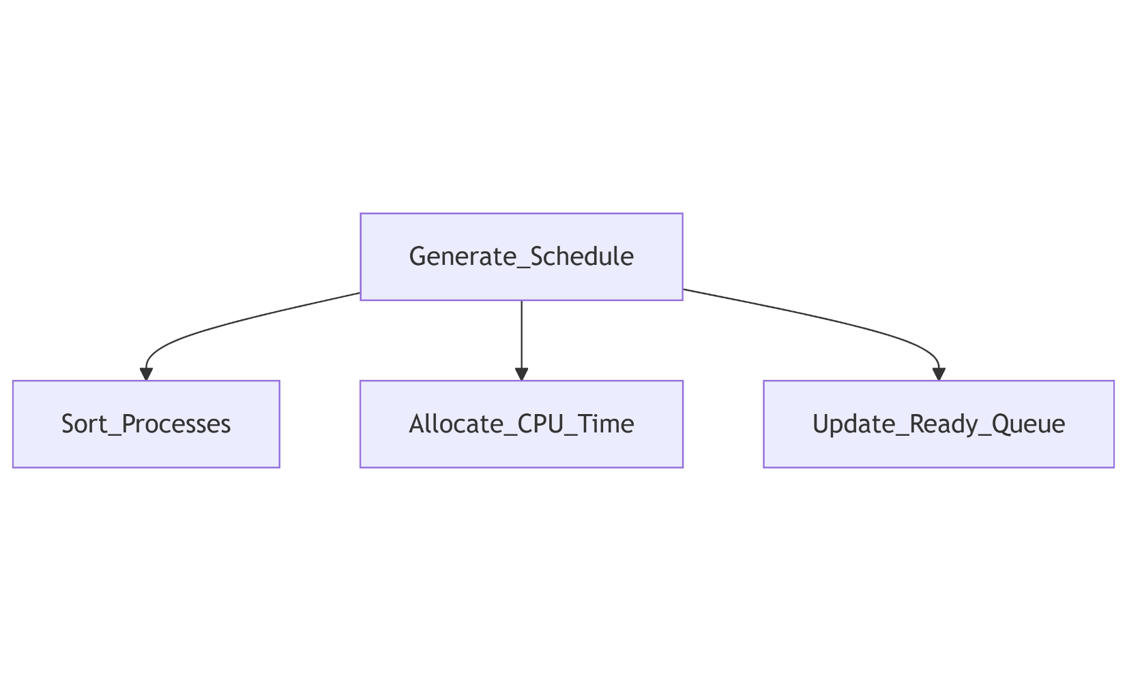

Level 2 — Refinement of Allocate_CPU_Time
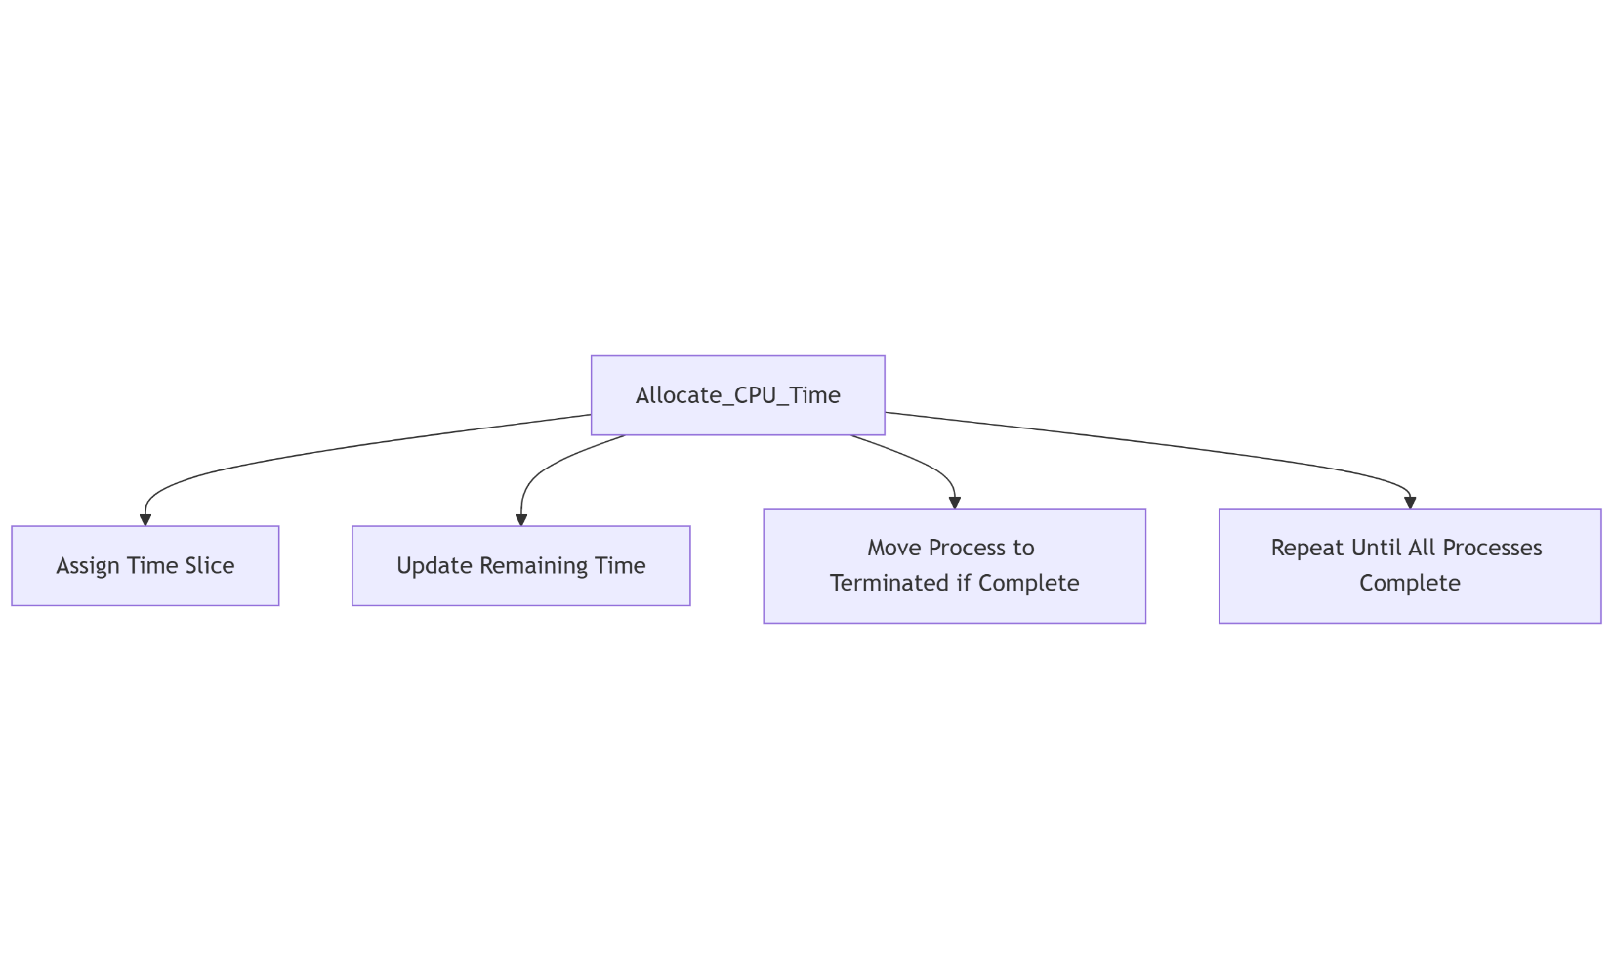

Full Stepwise Refinement Diagram
